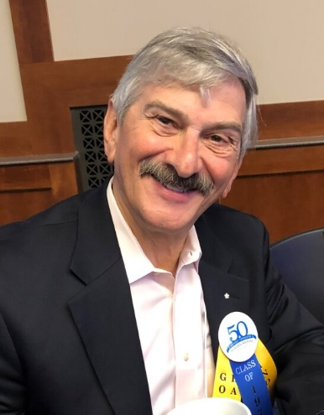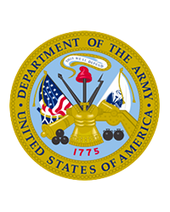

Obituary
Kelly Matthew Sharbel, Jr., 74, of Myrtle Beach, South Carolina and formerly of Alexandria, Virginia; passed away peacefully on October 9, 2022 at Grand Strand Regional Medical Center. He was born on September 30, 1948 in Nashville, Tennessee to the late Kelly Matthew Sharbel, Sr. and Margaret Johnson.
Along with his parents, Kelly is reunited in passing with his brother, Joseph Sharbel.
Kelly enjoyed playing golf, exercising, video games and the art of wood working. Kelly was fond of politics and he took great pleasure in volunteering within his community. He also took pride in being a member of St. Vincent de Paul and the Grand Strand Chapter of the Military Officers Association of America (MOAA). Kelly appreciated a good cigar with a good scotch, but most of all, Kelly loved time spent with family.
Kelly graduated from Middle Tennessee State University in 1970 and was the founder of the Theta Iota Chapter of the Sigma Nu Fraternity. Upon graduation he served in the Army prior to pursuing a career in journalism and politics. Kelly retired from federal civil service in the U.S. Government in 2000 as the Principal Deputy Assistant Secretary of Defense for Legislative Affairs. After retirement from federal service, he became a History Teacher in Virginia for 15 years.
Left to cherish Kelly’s memory is his wife, Nancy Sharbel of Myrtle Beach; daughter, Kimberly (Tristan) Downey of Aiken, SC; sons Andrew Sharbel of Leesburg, VA & Kelly Sharbel, III of Perry, Georgia; beautiful grandchildren Asher, Nora, Mae, and Miles; and many supportive friends and neighbors.
The family will gather to greet friends on October 14, 2022 at 12:00PM at Precious Blood of Christ Catholic Church, 1633 Waverly Road, Pawleys Island, South Carolina 29585, with a Mass of Christian Burial at 1:00PM.

